Call Center - Customization by Config

1. Add new search field to existing search page.

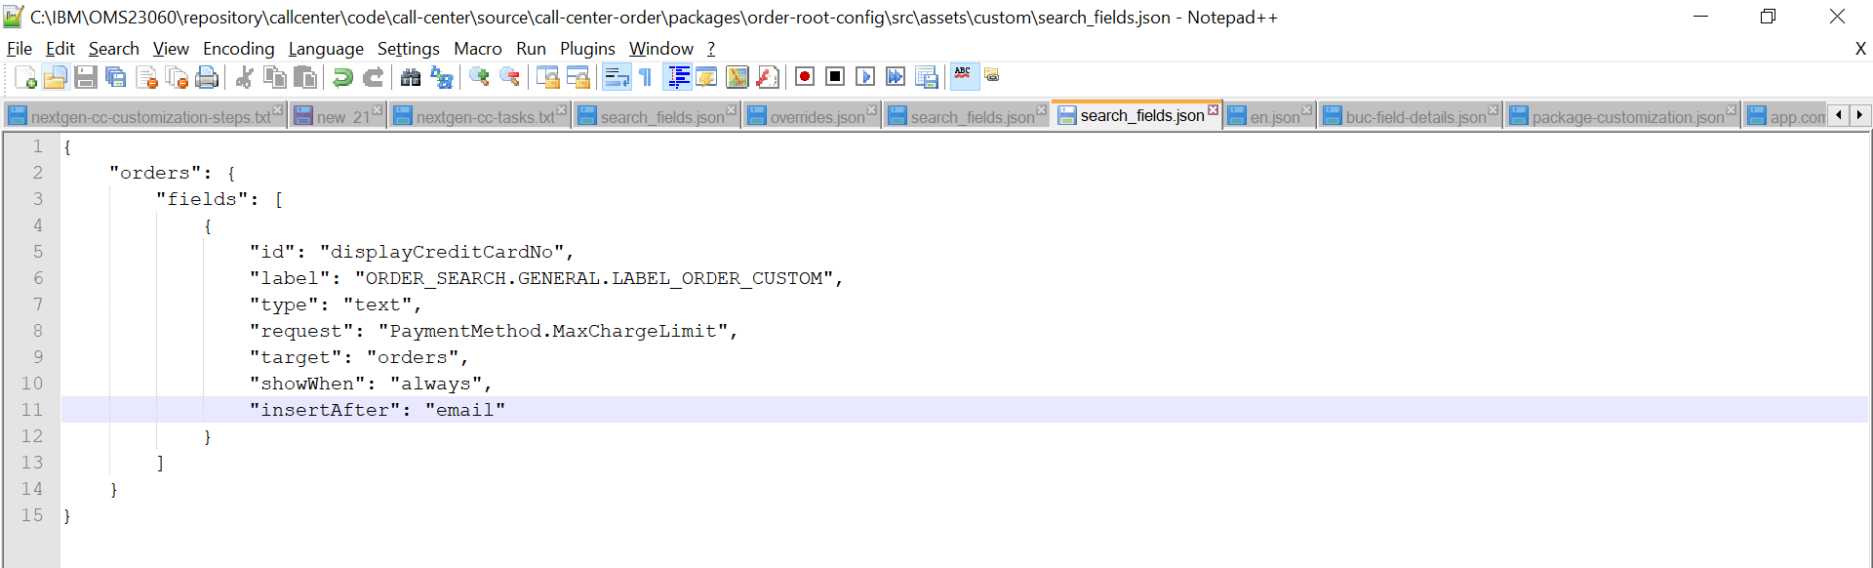

Restart Yarn as below

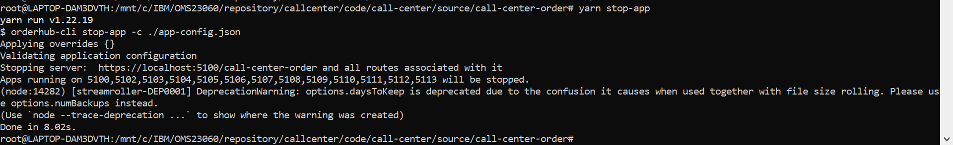



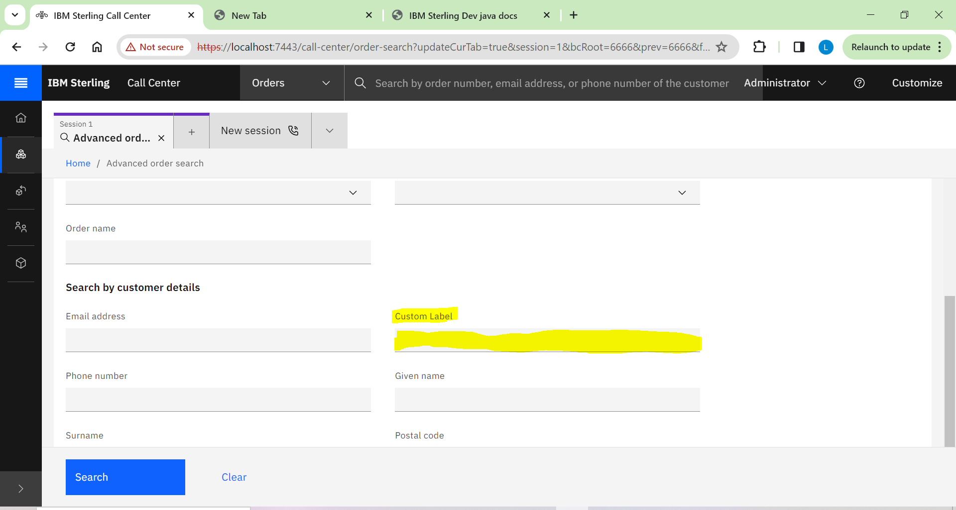

1. Add new summary field to existing detail page.

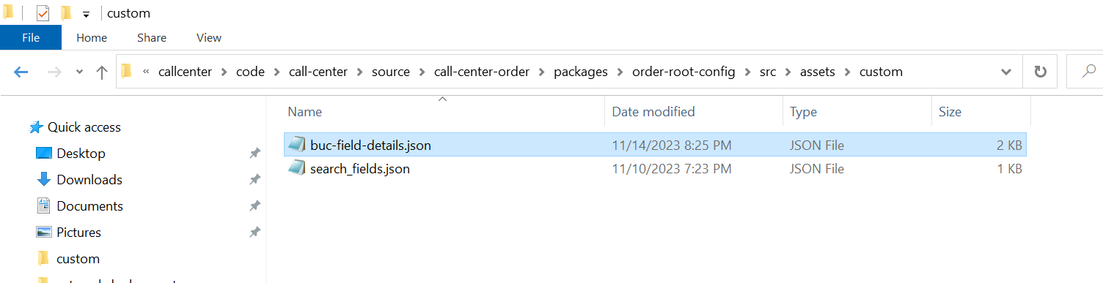

buc-field-details.json

|  |
| --- |
| {  "order-summary": {  "name": "order-summary",  "attributes": [  {  "id": "seller",  "name": "Seller",  "value": "",  "attrTID": "OrderStatusComponent-seller",  "type": "label",  "dataBinding": "SellerOrganizationName"  },  {  "id": "currency",  "name": "Currency",  "value": "",  "attrTID": "orderDetails - Currency",  "type": "dropdown",  "dataBinding": "PriceInfo.Currency",  "options": {  "editPermission": "",  "editAttr": "PriceInfo.Currency",  "fetch": {  "api": "icc.common-components.getCurrencyList",  "type": "mashup",  "parameters": {},  "response": {  "listAttribute": "CurrencyList.Currency",  "map": {  "id": "Currency",  "label": "CurrencyDescription"  }  }  }  }  }  ]  }  } |

Restart Yarn as below





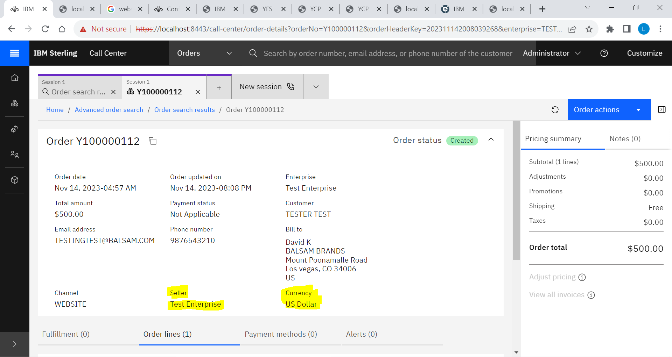

1. Add new address field to existing detail page.

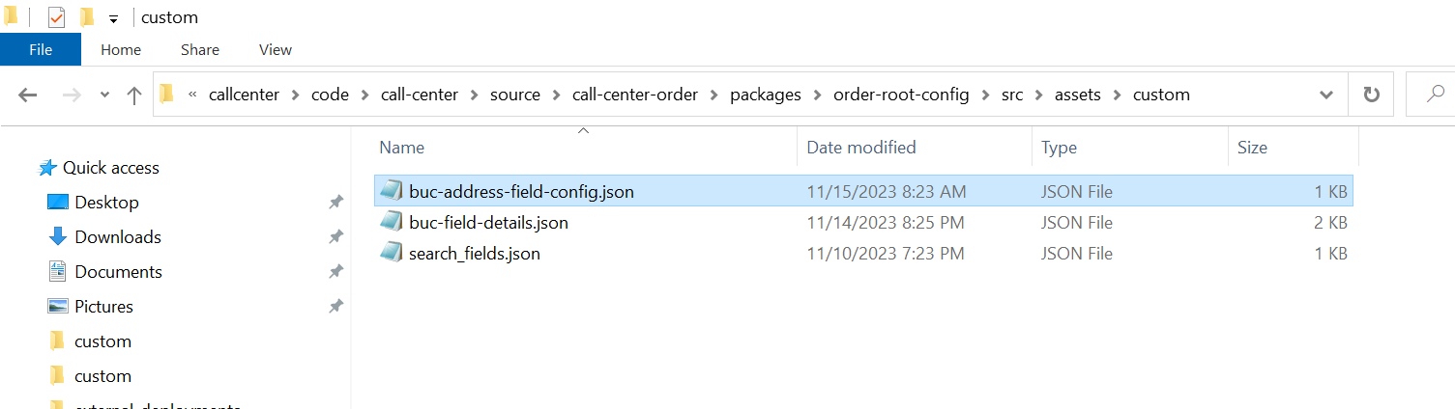

buc-address-field-config.json

|  |
| --- |
| {  "addressFormats": [  {  "id": "def-DEFAULT",  "displayOrder": {  "preference1": "Title FirstName LastName",  "preference2": "Company",  "preference3": "AddressLine1",  "preference4": "AddressLine2",  "preference5": "Country",  "preference6": "City, State ZipCode"    },  "mandatoryFields": "ZipCode,Country",  "contactInfo": ["FirstName","LastName","Title","EMailID","DayPhone","EveningPhone"],  "numberFields": "DayPhone,EveningPhone"  }  ]  } |

Restart Yarn as below





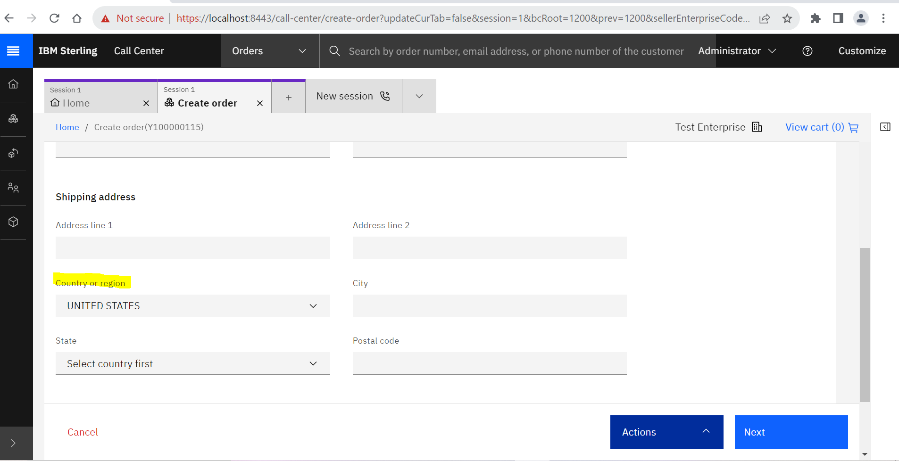

**Note: The display order of Country is changed to before City.**

1. Adding columns and actions to existing tables.

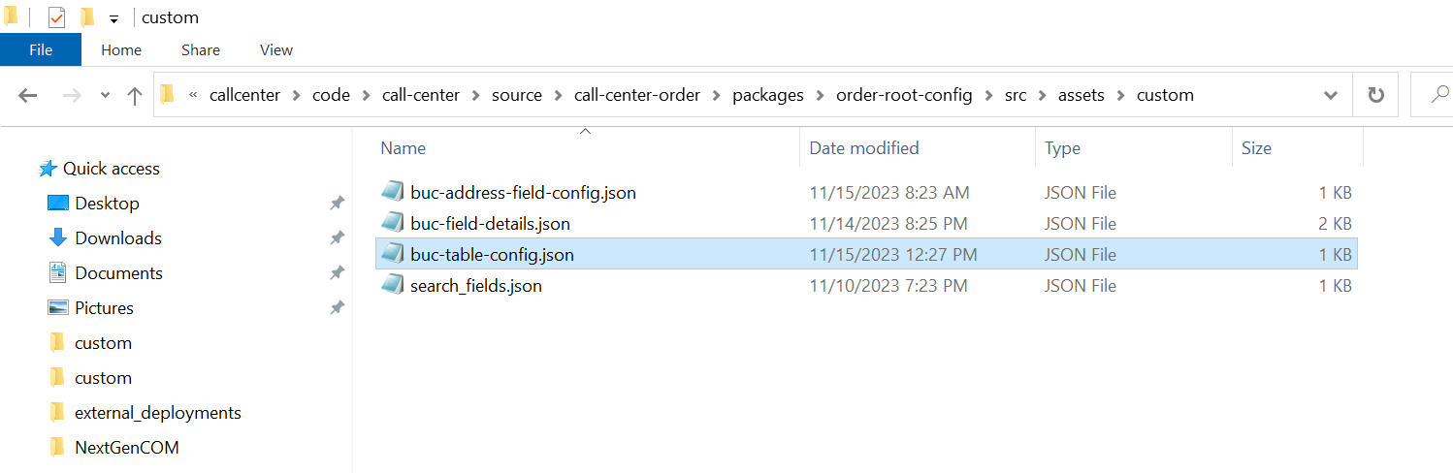

buc-table-config.json

|  |
| --- |
| {  "$schema": "../../../../../node_modules/@buc/common-components/assets/buc-table-config.schema.json",  "payment-activity-table": {  "name": "payment-activity-table",  "headers": [  {  "id": "chargetransactionKey",  "name": "PAYMENT_SUMMARY.REVIEW_PAYMENT_ACTIVITY_MODAL.LABEL_CHARGE_TRAN_KEY",  "sortable": false,  "dataBinding": "ChargeTransactionKey",  "sortKey": "",  "style": {  "min-width": "9rem"  }  }  ]  },  "order-table": {  "name": "order-table",  "headers": [  {  "id": "sellerOrganizationCode",  "name": "Seller",  "sortable": false,  "dataBinding": "SellerOrganizationCode",  "sortKey": "",  "style": {  "min-width": "9rem"  }  }  ]  }  } |

Restart Yarn as below





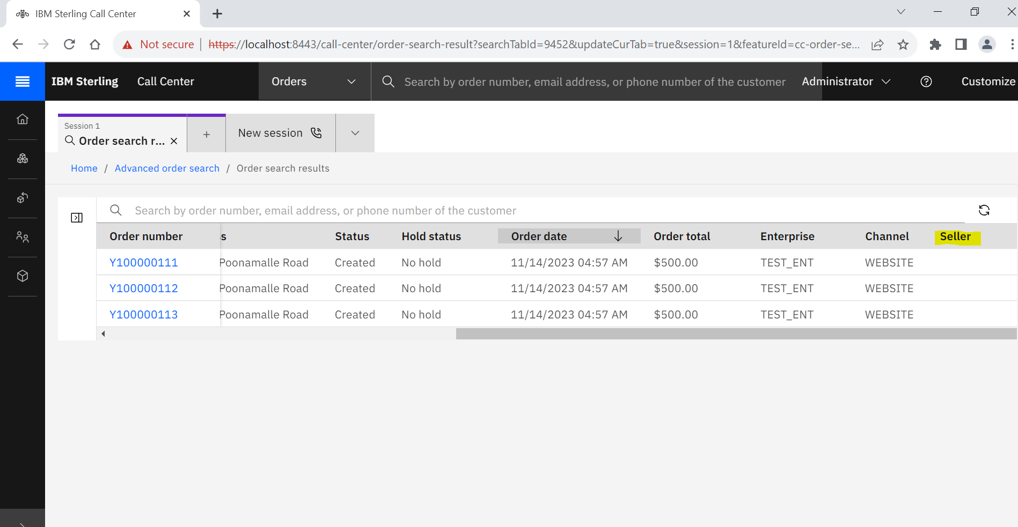

1. Customizing Login Page.

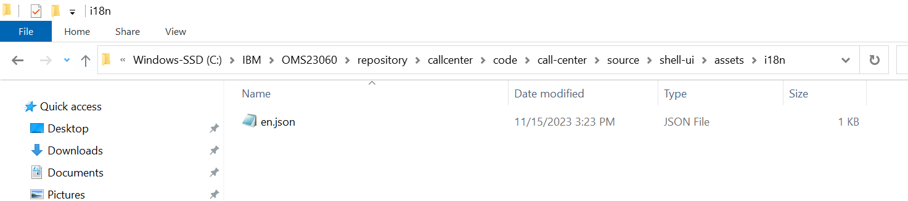

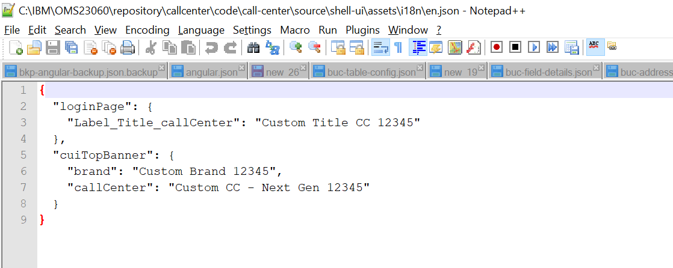

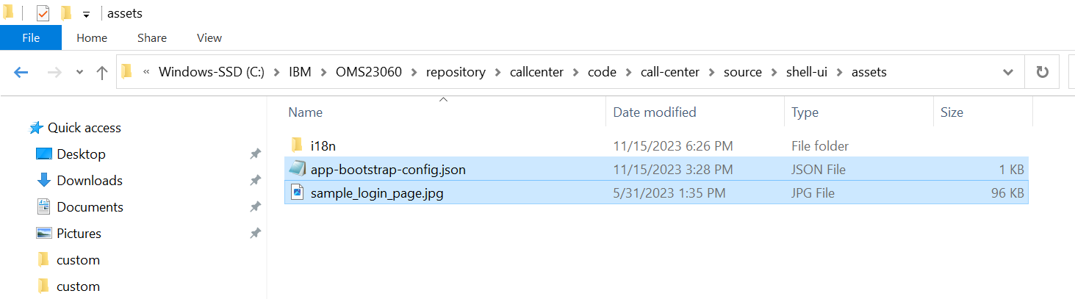

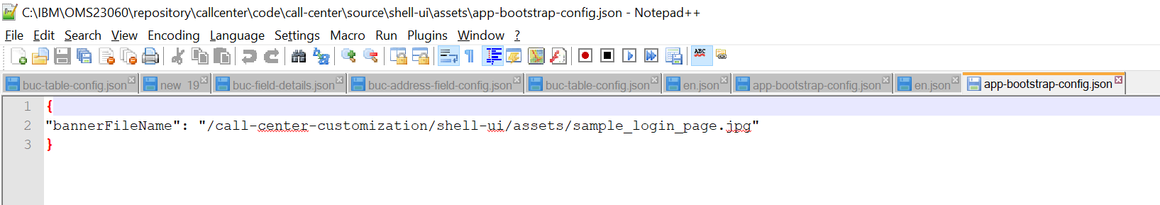

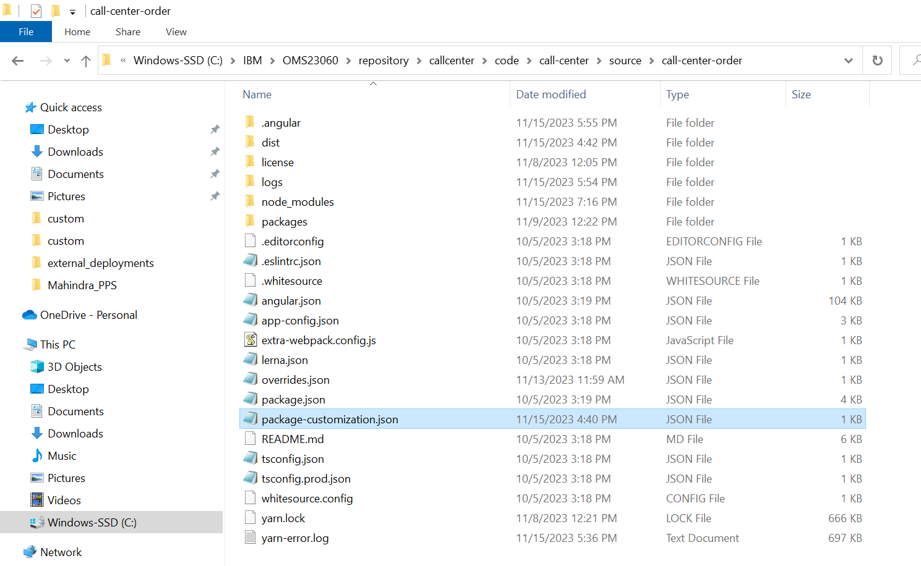

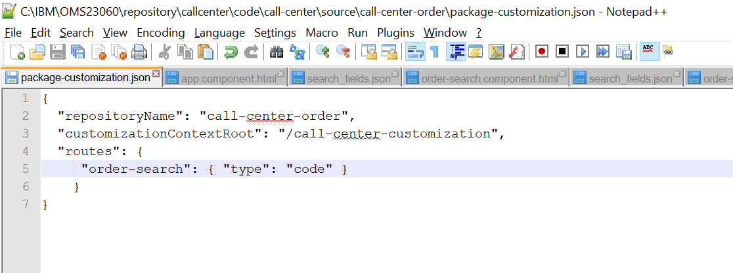

Run Build Customization script for build-ui as below



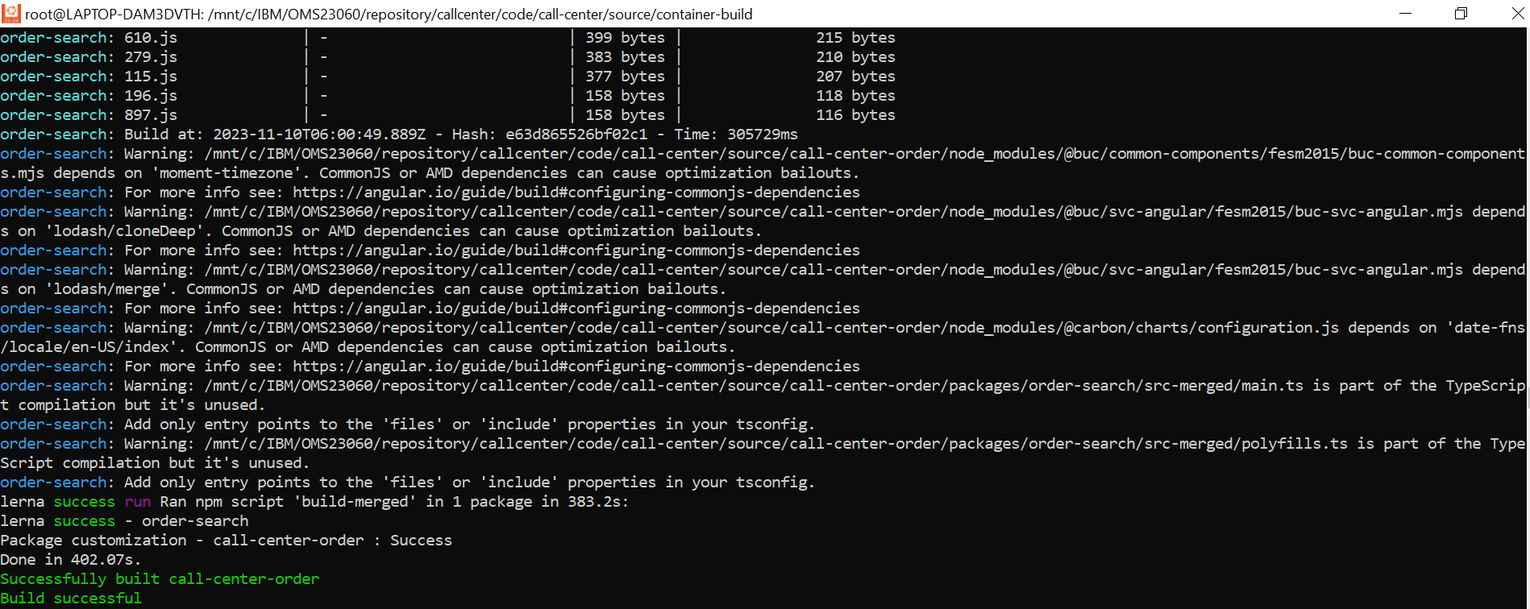

Run Build Customization script for package-jar as below

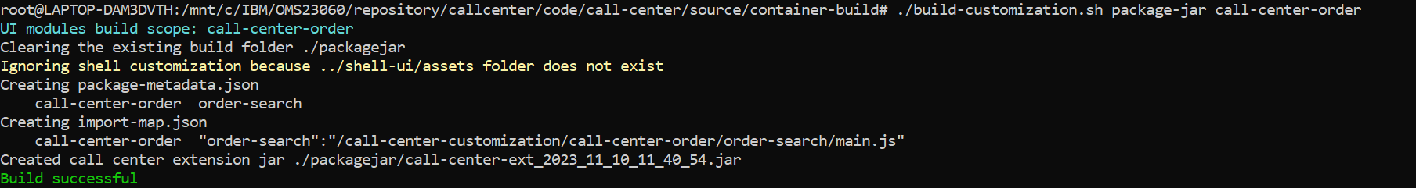

Copy the below jar file that got generated to some temporary folder and extract it as below

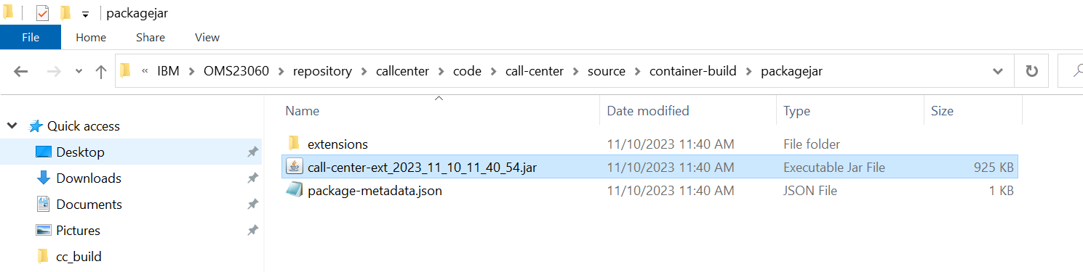

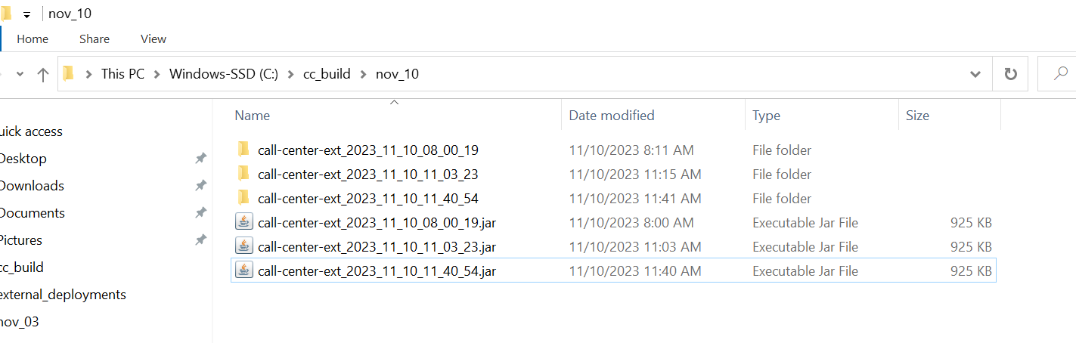

Run the below command to deploy the extensions.



Restart Yarn as below





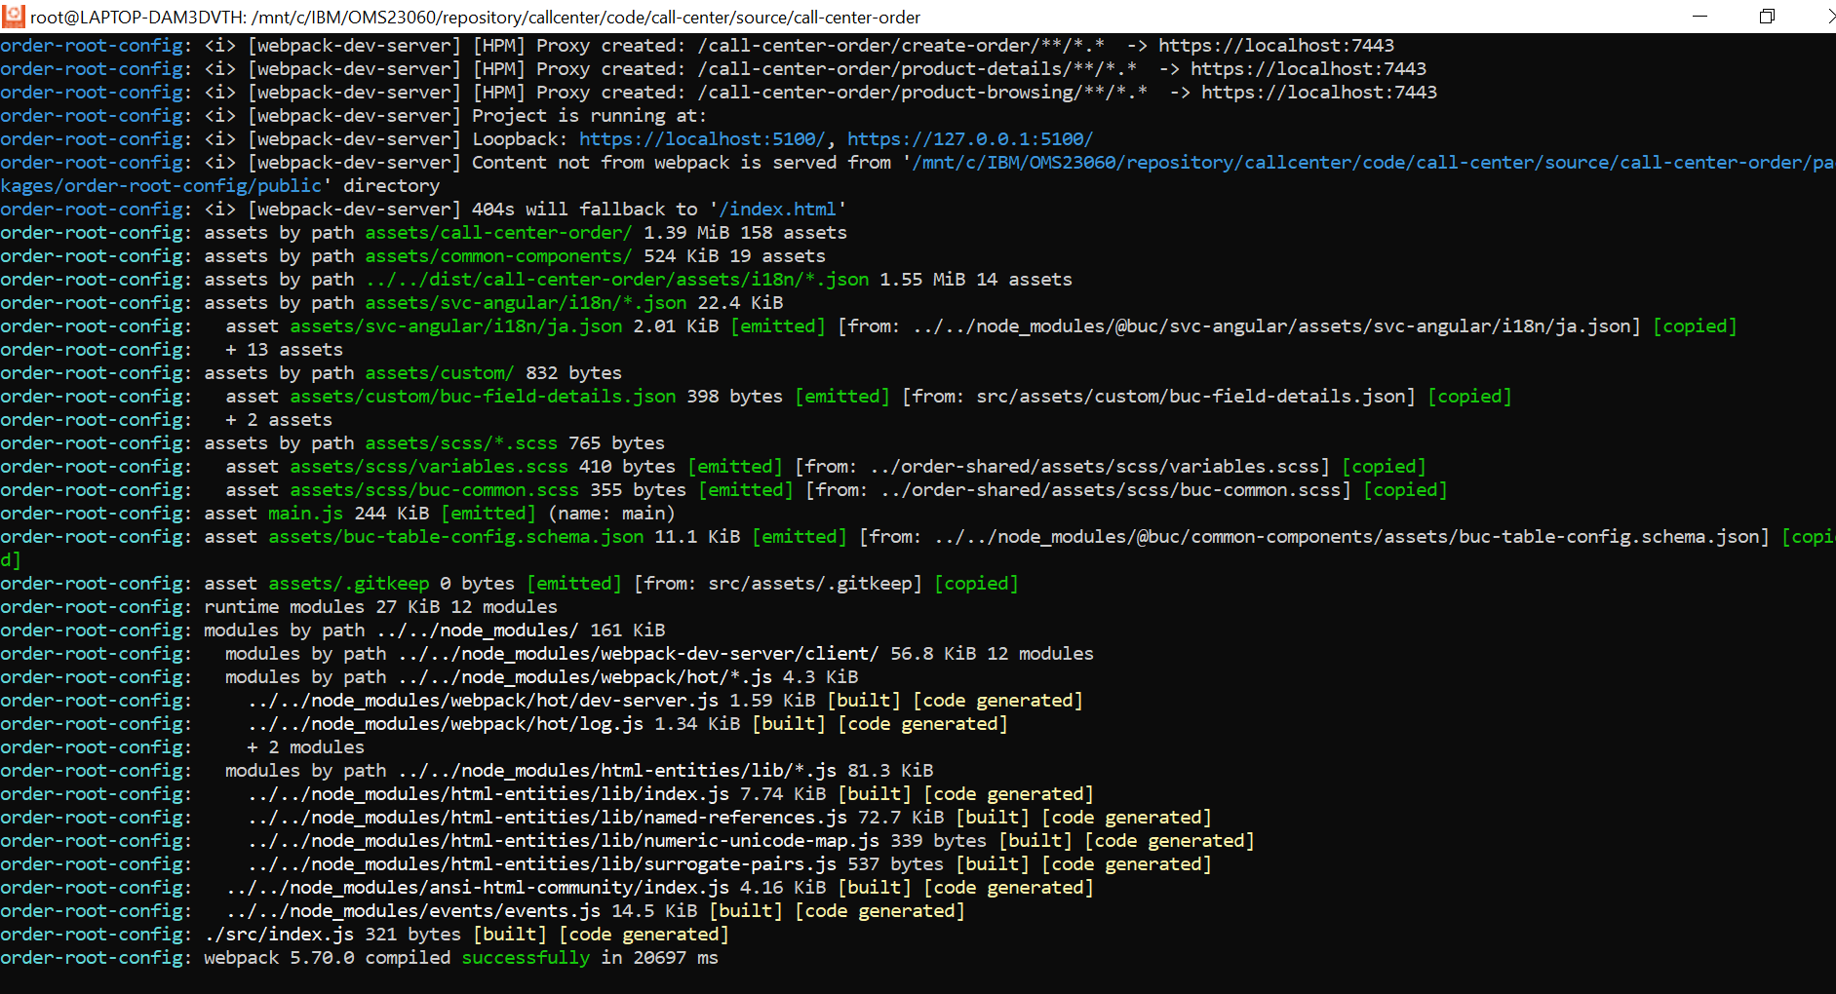

Once Yarn server started. Make sure nginx is also running and then login to cc and test the customization changes.